Headteacher: Mr S Marshall  St Ethelbert’s Catholic Primary School and Nursery  Dane Park Road  Ramsgate, CT11 7LS | Telephone: 01843 585555  Email: admin@stethelbertsschool.co.uk  Website: stethelbertsschool.co.uk

3rd July 2026

Latest Newsletter from Mr Marshall
Loving God,
Thank you for blessing our School Transition Day yesterday. We are grateful for the joy, kindness, and new beginnings shared throughout our school community. Guide and bless all our children and staff as they prepare for the new school year. May we continue to grow in faith, learning, and love, always following the example of Jesus.
Amen.

Dear St Ethelbert’s Community,

Yesterday was a lovely transition day. Myself and Ms Dowd kept walking around the classrooms to hear all the children happy and settled in their new classrooms. We could also hear the children at dismissal, very excited to tell their adults all about the day. Well Done everyone for a smooth transition.
I very much welcome our new families and children to the St Ethelbert's family and look forward to seeing them again in September.

I hope our current Year 6 children had a successful transition day to their new secondary school as well.

Year 6 leavers/transition
Here are the events for your diary:
• ‘Mystery at Magpie Manor’ Year 6 End of school production to Year 6 parents/grandparents – Thursday 9th July 7.00pm, church hall (entrance on Hereson Road next to the church), no restriction with audience numbers but please note it will be potentially busy and stuffy - Limited seats available. Children will have their dress rehearsal on Thursday 9th July at 1.15pm for Years 3-5
• Year 6 Leavers’ Disco (open to Years 3-6) – Wednesday 15th July 6.00pm - 7.30pm at £2.50 a ticket (all children must be picked up by an adult please). As it was such a success last year, the disco will be outside if weather permits. There will be sweets and drinks to buy at the disco. Our recommendation is a cap of £5.
• Year 6 Graduation and Afternoon Tea – Thursday, 16th July, 1:15pm – 3.00pm, speech from Mr Marshall, graduation to include handing out of leaver books and hoodies, followed by afternoon tea and book signing. No restriction in audience numbers so grandparents are welcome.
• Leavers’ Mass for Year 6 children, Thursday, 16th July 1.15pm outside (weather permitting). All welcome.

End of Term – Clubs and Wraparound care
Please note children break up for the summer on Friday 17th July at normal time. The last day for clubs and wraparound care will be Thursday 16th July. There will be no clubs or wraparound care on Friday 17th July.

God Bless

Mr Marshall
Headteacher

Water Safety during hot weather periods
During periods of hot weather, the risk of drowning can increase in children and young people. Even shallow water can be dangerous for eager young swimmers. Please always watch your children closely near paddlers, pools, and beaches.
Click on the links for water safety videos to watch together at home in relation to water safety and the water safety code to raise awareness and educate children in water safety and lifesaving skills.
https://www.youtube.com/watch?v=0FdfTeJoF2w
https://www.youtube.com/watch?v=FoEZQxSvH9g

PTFA AGM Tuesday 14th July 3:30pm
The PTFA plays a vital part in the school community, and all the parents and carers are warmly invited to attend the upcoming Annual General Meeting (AGM).
This is your chance to hear how the funds you have helped raise have been used for the benefit of the children at the school.
The AGM is also an opportunity for you to elect the PTFA Committee, to represent the association throughout the forthcoming academic year. Nominations should be sent in advance of the AGM for existing committee members willing to stand for re-election and for anyone wishing to stand as an Officer or Ordinary Committee Member for the first time.
Please complete the form if you wish to be nominated and return by 3 pm on Friday 10th July to the PTFA at ptfa@stethelbertsschool.co.uk.
If anyone would like to discuss the roles in the PTFA or would consider volunteering with support initially, please feel free to email us.

PTFA Leavers Disco: Wednesday, 15th July 6-7.30pm

We are delighted to invite our Junior children to join us for a special Outdoor Leavers' Disco as we celebrate our Year 6 leavers.
The evening will feature music, games, and a variety of fun stalls, making it a wonderful opportunity for children to celebrate together.
Please book a space via 'School money', £2.50 entry. There will be Hot dogs, Doughnuts, Candy floss, Sweets, Drinks, Games, and Crafts, so please bring some change.

Year 3 Swimming – Term 6
The Year 3 swimming will start on Friday, 5th June at Ramsgate Swimming Pool. The children will start their lesson at 1.10pm and finish at 1.55pm. The children will be back at school and ready to be dismissed as normal.
The programme will take place every Friday up to and including the 17^{th of} July 2026. Your child will need to bring swimwear, goggles and a towel on these days. No spray deodorants are allowed, only roll-on. They must wear a coat as they may be cold walking to and from the pool.

Congratulations
Congratulations to two of our pupils Bailey and Betty, who were baptised by Fr Jonathon on Saturday.
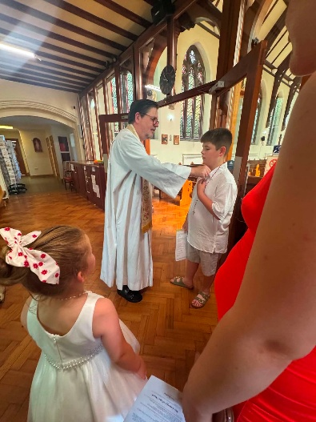
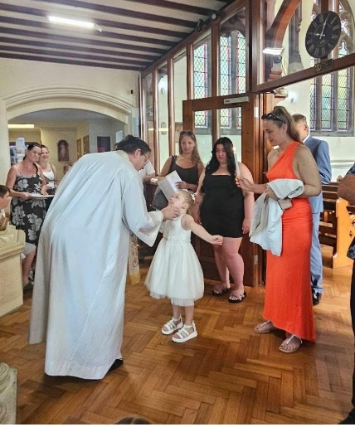

Water bottles and fresh fruit/veg snacks

To help keep our children healthy and ready to learn, please ensure your child brings a filled water bottle to school each day which they can then refill throughout the day. The bottle should be filled with water only and not juice. We also ask that any healthy snacks sent in from home are cut into bite-size pieces to minimise choking hazards and support safe eating habits. Children will be encouraged to sit and eat before playing, helping them enjoy their snacks calmly and safely.

Diary Dates 2026-27
Please find attached diary dates for 2026-27. While we aim to keep to this, please keep an eye on weekly updates as some dates or times may need to change. We will notify you immediately if any changes are made.

The Archbishops School – Summer Camp

Taking place at The Archbishop’s School, Canterbury, this exciting programme is designed to provide children with a fun, engaging, and developmental football experience throughout the summer holidays.
Over the three weeks, players will benefit from:
- Skill development and technical training
- Fun games and competitions
- Small-sided matches
- A positive and inclusive environment for all abilities
- Coaching aligned with the values and standards of Millwall Community Trust
Whether your child is looking to improve their football skills, stay active during the holidays, or simply enjoy playing with friends, our summer camp offers the perfect opportunity.
Camp Details:
Venue: The Archbishop’s School, Canterbury
Delivered in partnership with Millwall Community Trust
3-Week Summer Football Camp
Book your place today:
https://www.tickettailor.com/events/plus1sportscoaching/2280448
If you have any questions, please do not hesitate to get in touch.
We look forward to welcoming your child for an unforgettable summer of football.

Thanet Family Hubs
Below are details of some upcoming courses taking place at Thanet Family Hubs
Autism Awareness - 3-week course
Explore, recognise and celebrate the unique strengths and abilities of autistic individuals in this empowering course.
- Newington Family Hub, Thursdays 11th June - 2nd July: 10am - 12pm
- Northdown Road Family Hub, Fridays 3rd July - 17th July: 10am-12pm
First Aid for Babies
Join in our practical and supportive workshop to learn vital first aid techniques to confidently care for your baby in an emergency.
- Cliftonville Family Hub - Monday 8th June: 9.30am-11.30am
- Priory Family Hub - Tuesday 21st July: 12.30pm - 2.30pm

Please note that these sessions are delivered by Kent Adult Education (KAE) and are not run by the Family Hubs, however they are being held within our premises. These courses provide valuable information and support for families and professionals, and we encourage you to share them with anyone who may benefit. Further details, including dates, times, and booking information, can be found in the attached leaflets.

SEND
Please click here for the latest Kent County Council Newsletter for SEND. Here you will find the latest news on Children's mental health, KCC SEND progress to date and further general advice, guidance and support.

Please click here for the SEND Newsletter Special Edition

Children showing our school values this week
Year Group | Class Name/Saint Name | Child | Value | Reason for Value
Nursery | United Kingdom  Saint George | Olueze | Knowledge | Really engaging with learning activities as well as during phonic and maths sessions!
Nursery | United Kingdom  Saint George | Nellie | Thoughtfulness | Always having amazing manners and being kind to everyone!
Reception | Poland  Saint Jadwiga | All of Reception | Inclusion | Being supportive to each other when moving up for transition day!
Year 1 | Romania  Saint Andrew | Beatrise | Thoughtfulness | Consistently making kind, sensible choices and always trying your best
Year 1 | Romania  Saint Andrew | Archie | Knowledge | Your brilliant focus and contributions during our geography lesson.
Year 2 | Hungary  Elizabeth of Hungary | Ehvehlyn-Marie | Knowledge | Her excellent construction of a 3-D pyramid using spaghetti and marshmallows
Year 2 | Hungary  Elizabeth of Hungary | Rose | Inclusion | Ensuring that our new student felt welcome on her transition day
Year 3 | Japan  Paulo Miki | Jacob | Inclusion | Willingly seeking out adults and children to help any way he can
Year 3 | Japan  Paulo Miki | Archie | Knowledge | Working on his presentation and showing us his amazing handwriting.
Year 4 | Italy  Catherine of Siena | Nabilah | Inclusion | Always treating others with respect and kindness
Year 4 | Italy  Catherine of Siena | Carter | Knowledge | Being a super science technician/helper during an experiment where we explored the viscosity of liquids.
Year 5 | India  Saint Mother of Teresa | Holly | Inclusion | Always taking time to check in on others and make sure they are ok
Year 5 | India  Saint Mother of Teresa | Erin | Knowledge | Putting so much effort into improving her writing
Year 6 | France  Saint Vincent de Paul & Saint Therese of Lisieux | Phoebe | Thoughtfulness | Thinking ahead – Phoebe has been excellent at designing and painting props
Year 6 | France  Saint Vincent de Paul & Saint Therese of Lisieux | Elliot | Inclusion | Working so well with a group to perfect his dance skills; smiling and enthusiastic.



Well done!

Class Masses
If you would like to join us for a class Mass, then you are very welcome. Children lead the Mass with readings and bidding prayers.

Date | Year Group attending Mass
9th July | Year 3
16th July | Year 6 Leavers Mass

Mass will be on Thursday mornings at 9.30am in St Ethelbert’s church

Attendance this academic year…


Our attendance policy states that we aim for a 100% attendance

Reception | 94.2%
Year 1 | 95.6%
Year 2 | 97.3%
Year 3 | 89.3%
Year 4 | 97.5%
Year 5 | 93.5%
Year 6 | 66.4%
Whole School this week | 90.6%
Whole School academic year to date | 94.6%
National Average academic year to date | 94.8%

PLEASE NOTE – IF YOU NEED TO CONTACT A MEMBER OF THE WRAPAROUND CARE STAFF AFTER 4PM THE NUMBER TO CALL IS 07400 170519

DIARY DATES

2025/26

June 2026
26th/29th/30th Bikeability
July 2026
9th Year 6 dress rehearsal to school - 1:00pm
9th Year 6 Production to parents - 7:00pm
15th End of Year Reports to parents
15th Year 6 Disco -6.00pm - 7.30pm
16th Year 6 Leavers Mass, Graduation and Afternoon Tea - 1.00pm
17th Benediction 1.15pm
17th Nursery Graduation 2.30pm
17th End of Term 6 for children
20th INSET day (4 of 5)
21st INSET day (5 of 5)

21st END OF TERM 6

PLEASE NOTE THERE WILL BE NO AFTER SCHOOL CLUBS
OR WRAPAROUND CARE ON FRIDAY 17TH JULY

2026-27
September 2026
1st/2nd INSET DAYS (1&2 of 5)
3rd TERM 1 STARTS FOR CHILDREN
3rd/4th Reception in part time
4th Whole School Mass
7th Reception in full time
10th September Kent Test
14th September – Individual and Sibling photos
21st Feast of Saint Matthew
25th Non-uniform for CAFOD - cash donation
30th Book Fair arrives

October 2026
1st Autumn Census
5th World Teacher’s Day
5th CAFOD Assembly
7th Book Fair collected
18th Feast of Saint Luke
19th Sharing the Learning - parents invited in from 2.30pm - thrive focus
19th Multiplication Table Check parent’s info meeting 3.20pm
20th/21st Parents evening - 3:20 - 6:00pm
22nd END OF TERM 1
23rd INSET DAY (3 of 5)

